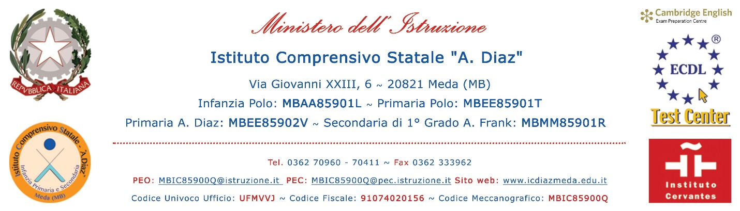
SCELTA DEI LIBRI DI TESTO PER L'ANNO SCOLASTICO ______ / ______

Protocollo __________
Data ______________
Riservato all'Ufficio Segreteria

 | NUOVA ADOZIONE |  | CONFERMA | DA ACQUISTARE: | Sì | No
MATERIA: _______________________________________________________________________
CLASSE: ____________________ SEZIONE: ____________ PLESSO: ______________________
AUTORE: __________________________ TITOLO: _____________________________________
CASA EDITRICE: _________________________________________________________________
Codice libro ISBN
N.B.: inserire il codice ISBN e NON il codice del libro digitale.
PREZZO IN EURO: ________________________
R E L A Z I O N E
________________________________________________________________________________________________________________________________________________________________________________________________________________________________________________________________________________________________________________________________________________________________________________________________________________________________________________________________________________________________________________________________________________________________________________
I DOCENTI
___________________ | ___________________
___________________ | ___________________
___________________ | ___________________
___________________ | ___________________
___________________ | ___________________
Meda, ____________________

